Experiment-1:Creating Domain Specific Generalized Knowledge Graph(DS-GKG) for MITRE ATT&CK
Experiment-1:Creating Domain Specific Generalized Knowledge Graph(DS-GKG) for MITRE ATT&CK 1
Aim: 1
Introduction about MITRE ATT&CK 1
Procedure[To do]: 2

Aim:
To create a Generalized Knowledge graph for MITRE ATT&CK using python ,Neo4j Graph database and LLM.

Introduction about MITRE ATT&CK
MITRE ATT&CK® is a globally-accessible knowledge base of adversary tactics and techniques based on real-world observations. The ATT&CK knowledge base is used as a foundation for the development of specific threat models and methodologies in the private sector, in government, and in the cybersecurity product and service community.
With the creation of ATT&CK, MITRE is fulfilling its mission to solve problems for a safer world — by bringing communities together to develop more effective cybersecurity. ATT&CK is open and available to any person or organization for use at no charge.
MITRE ATT&CK is a widely used cybersecurity framework developed by MITRE to document and analyze adversary tactics, techniques, and procedures (TTPs) based on real-world cyberattacks. It helps organizations understand attacker behavior, detect threats, assess risks, and improve defensive strategies. The framework organizes attacks into tactics (attacker goals), techniques (methods used), and procedures (specific implementations), enabling analysts to map and predict attack patterns. The survey paper reviews more than 50 research contributions that apply MITRE ATT&CK in areas such as behavioral analytics, red teaming, defensive gap assessment, and cyber threat intelligence enrichment. It also compares ATT&CK with other security frameworks like Cyber Kill Chain and STRIDE, highlighting its strengths in threat modeling and attack analysis across enterprise, mobile, and industrial control system environments. The paper further discusses challenges, research gaps, and future directions for improving cyber threat intelligence and security analytics using the ATT&CK framework.

Work Flow Diagram
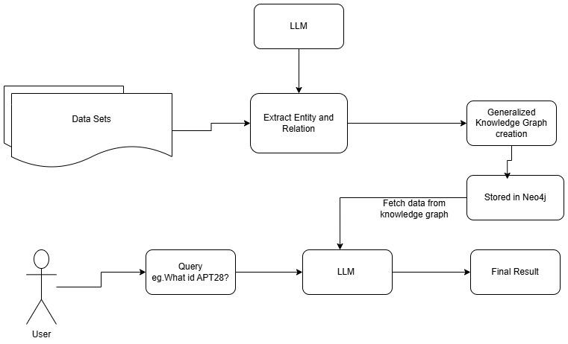

Procedure[To do]:
- Download the dataset from the below link
  - https://ieee-dataport.org/documents/mitre-attack-dataset-knowledge-graph-enhanced-rag-cyber-threat-intelligence
  - Data sets available in below google drive link
    - Attackmitre.xlsx - contains column such as
      - APT group ID
      - Group technique/tactic ID_>referred with Tactic ID column of MitreEnterprise.Xlsx
      - SoftwareID
      - Software Techniques
      - Software References
    - MitreEnterprise.Xlsx -contains column such as
      - Tactic ID
      - Tactic Name
      - Description
      - Mitigation Steps
      - Examples
- Write logic to create Knowledge graph using LLM from Attackmitre.xlsx,in which Group technique/tactic ID is referring Tactic ID column of MitreEnterprise.Xlsx using python
- The created knowledge graph has to be stored in the Neo4j database.
- Finally display the generalized graph for MITRE ATT&CK.
- The knowledge graph has to be queried for knowing about all the APT group IDs

Screen Shots

Conclusion
Thus Domain Specific Generalized Knowledge Graph(DS-GKG) for MITRE ATT&CK is created using python.

https://attack.mitre.org/
Bader Al-Sada, Alireza Sadighian, and Gabriele Oligeri. 2024. MITRE ATT&CK: State of the Art and Way Forward. ACM Comput. Surv. 57, 1, Article 12 (January 2025), 37 pages. https://doi.org/10.1145/3687300

